DOCKER COMMANDS
List, Push and Pull
- $ docker ps // to see the running containers
- $ docker ps -a // to see all existing containers
- $ docker images // to list the docker images
- $ docker images image_name // to list diff versions of a container
- $ docker image pull --all-tags nginx // to download all versions of an image
- To Push an Image to Docker Hub
  - $ docker login (enter username and password)
  - $ docker tag image_name shubhamsayon/image_name:v1 (here image_name:v1 is just the tag for ur image on docker hub)
  - $ docker push shubhamsayon/image_name:v1

Attach and Execute commands on a running Container
- $ docker container attach my-busybox
(To exit out of the attach terminal type exit. As soon as you exit from the terminal the busybox container will automatically stop)
- $ docker exec -it my-busybox
(Once you exit , the container still keeps running unlike the atatch command)

Port Forwarding/Mapping
- $ docker run -itd -p 80001:80 shubhamsayon/samplephp:v1
- $ docker port container_name
(this will display the port mapping)

Container Run , Start , Stop and Rename
- $ docker container run -itd --rm --name container_name image_name:version
eg: $ docker container run -itd --name my_busybox busybox:latest
- $ docker container run -it --rm --name container_name image_name:version
- $ docker run container_id
- $ docker stop container_id
- $ docker rename container_oldName container_Newname
(eg: docker rename my_busybox_C my_busybox_B)

Erasing Containers and Images
- $ docker rm container_name
- $ docker rm container1_id container2_id container3_id
(This removes multiple containers in a line)
- $ docker rm container_name --force
(this will remove a running container forcibly)
- $ docker container prune
( this will remove all stopped containers )
- $ docker rmi image_id

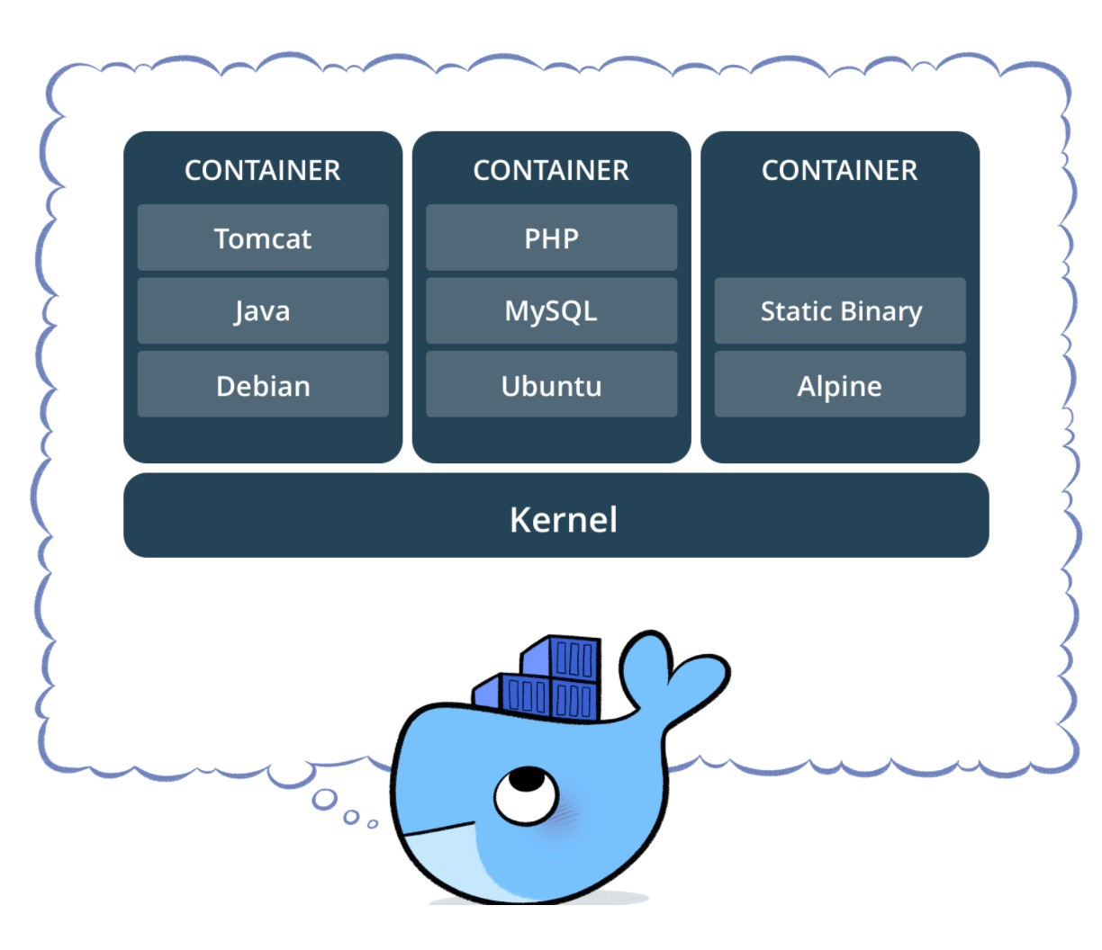
DOCKER COMPOSE

Compose is a tool for defining and running multi-container Docker applications. With Compose, you use a YAML file to configure your application’s services. Then, with a single command, you create and start all the services from your configuration

Installing Docker Compose
1)
sudo curl -L "https://github.com/docker/compose/releases/download/1.22.0/docker-compose-$(uname -s)-$(uname -m)" -o /usr/bin/docker-compose

2) sudo chmod +x /usr//bin/docker-compose

Structure of Docker Compose File

- YAML
The YML file type is primarily associated with Javascript by YAML. YAML stand for "YAML Ain't Markup Language;". It uses a text file and organizes it into a format which is Human-readable. YAML may be used with multiple platforms of programming languages such as PHP, Python, Ruby, Perl, Javascript amongst others.

- Nesting is done in YAML via indentation
  - It has 3 basic datatypes
    - Scalaras (Strings and Numbers)
    - Sequences(Arrays and Lists)
    - Mappings(Hashes and Dictionary(Key value pairs))

A docker-compose.yml looks like:

version: '3'
services:
web:
build: .
ports:
- "5000:5000"
volumes:
- .:/code
- logvolume01:/var/log
links:
- redis
redis:
image: redis
volumes:
logvolume01: {}

Creating the Docker Compose File

$ mkdir wordpress
$ cd wordpress
$ vi docker-compose.yml

wordpress:
image: wordpress
links:
- wordpress-db:mysql
ports:
- "7070:80"

wordpress-db:
image: mariadb
environment:
MYSQL_ROOT_PASSWORD: admin

phpadmin:
image: corbinu/docker-phpmyadmin
links:
- wordpress-db:mysql
ports:
- "8181:80"
environment:
MYSQL_USERNAME: admin
MYSQL_ROOT_PASSWORD: admin

Save and get back to main terminal window. :wq

Execute the compose file :
$ docker-compose up -d

Docker Compose Commands:
$ docker-compose up -d // start the services mentioned in docker compose
$ docker-compose config // view docker copose file on terminal
$ docker-compose config --services // to view specific info
$ docker-compose images // to view images used in docker file
$ docker-compose logs // to check docker compose logs
$ docker-compose ps // to list containers running in docker compose
$ docker-compose top // to display processes running in each of the containers
$ docker-compose down // clean up command to docker-compose up

